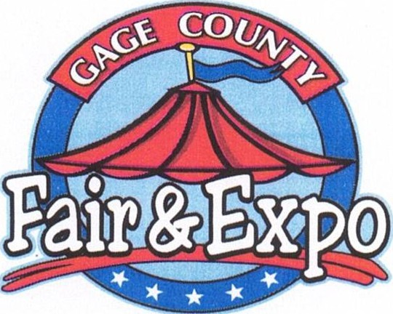

P.O. Box 671
Beatrice, NE 68310
402.223.FAIR (3247)
www.gagecountyfair.com

GAGE COUNTY AGRICULTURE SOCIETY SCHOLARSHIP APPLICATION
The Gage County Agriculture Society will award four (4) $500 Scholarships to four graduating Seniors, who plan to continue their education.

The following qualifications will be required.

- Have participated in events sponsored by the Gage County Agriculture Society
(Examples include exhibiting, volunteering, working, and/or other community service for the benefit of the Gage County Ag Society)

- Hold a 2.0 grade point average on a 4.0 point scale

- Will attend either a two or four year college or it's equivalent, in the judgment of the committee.

- Have demonstrated support in their community and school

- Economic need shall not be considered in the selection of students.
Submit this application, along with essay and letter of recommendation by March 15. Submit Applications to: Gage County Agriculture Society
Box 671
Beatrice, NE 68310

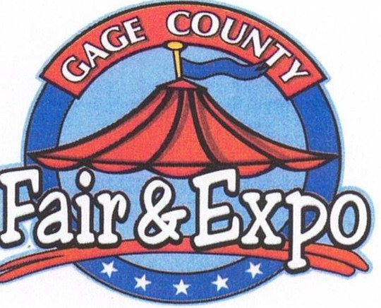

P.O. Box 671
Beatrice, NE 68310
402.223.FAIR (3247)
www.gagecountyfair.com

GAGE COUNTY AGRICULTURE SOCIETY SCHOLARSHIP APPLICATION

Name: Address:

Phone: Date of Birth:

Parents Name and Address:, _

Career Choice:

Choice of College:

*Please note that you may use additional pages, if needed

How do you plan to finance your education?

School Activities, Awards and/ or Honors:

P.O. Box 671
Beatrice, NE 68310
402.223.FAIR (3247)
www.gagecountyfair.com
t5nGAGE m f t,f

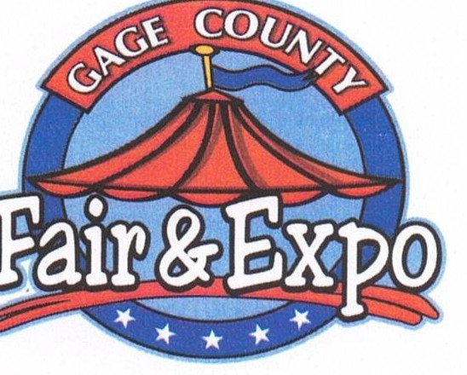
School Activities, Awards and/ or Honors (cont):

Community, Church or other Activities you have participated in:

P.O. Box 671
Beatrice, NE 68310
402.223.FAIR (3247)
www.gagecountyfair.com
t: AGE f t; f

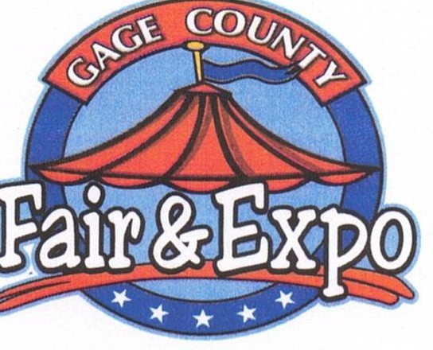
Projects in 4H, FFA, and/ or other organizations you have participated in:

Part-time jobs held (list current first):

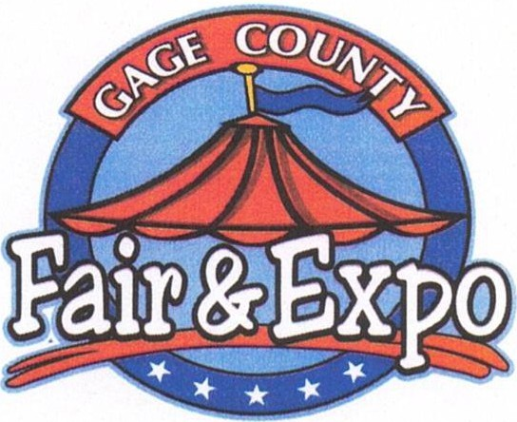

P.O. Box 671
Beatrice, NE 68310
402.223.FAIR (3247)
www.gagecountyfair.com

On an attached page, please prepare a statement (400 words or less) to the following questions. The statement you make is valuable to the committee, in making the decision on your application.

- What activities sponsored by the Gage County Agriculture Society have you participated in?

- How have you personally benefited by participating in events sponsored by the Gage County Agriculture Society?

- What are the challenges that you see Agriculture in Nebraska will need to meet in years to come?

- What do you think you'll be doing 5 to 10 years from now?

Please return this application, essay and letter of recommendation by March 15.

Mail to: Gage County Agriculture Society Box 671
Beatrice, NE 68310

Recipients will be notified by May 1. Scholarship will be paid to the recipient and the institution of his/ her choice jointly when proof of enrollment and acceptance by the school has taken place.
I certify that the statements made by me in this application are true, complete and correct to the best of my knowledge and belief, and are made in good faith.
Signature
Date

