P.O. Box 671
Beatrice, NE 68310
402.223.FAIR (3247)
www.gagecountyfair.com

EVIE CRAWFORD SCHOLARSHIP APPLICATION
The Gage County Agriculture Society will award four (1) $500 Scholarship to a graduating Senior who was a participant in the 2023 Livestock Premium Auction and plans to continue their education after graduating.

The following qualifications will be required.

- Have participated in the 2023 Livestock Premium Auction and be in the graduating class of 2024

- Hold a minimum 2.0 grade point average on a 4.0 point scale

- Will attend either a two or four year college or it's equivalent, in the judgment of the committee.

- Have demonstrated support and good character in their community and school.

- Economic need shall not be considered in the selection of students.

- The scholarship will be awarded at the 2024 Livestock Premium Auction held at the Gage County Fair.

Submit this application, along with an essay and letter of recommendation by March 15.

Submit Applications to: Gage County Agriculture Society
c/o Evie Crawford Scholarship Box 671
Beatrice, NE 68310

P.O. Box 671
Beatrice, NE 68310
402.223.FAIR (3247)
www.gagecountyfair.com
6.,,GAGE ,,;..,, f-.: f--,,

EVIE CRAWFORD SCHOLARSHIP APPLICATION

Name: _ Address:

Phone: Date of Birth: _ Parents Name and Address: _

Career Choice: _ Choice of College:
*Please note that you may use additional pages, if needed

How do you plan to finance your education?

School Activities, Awards and/ or Honors:

P.O. Box 671
Beatrice, NE 68310
402.223.FAIR (3247)
www.gagecountyfair.com
n· GAGE m f t, f

School Activities, Awards and/ or Honors (cont):

Community, Church or other Activities you have participated in:

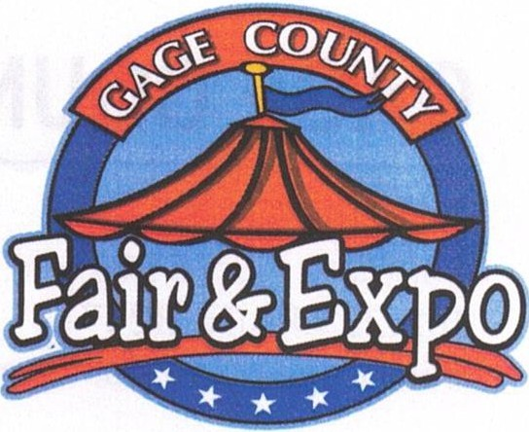

P.O. Box 671
Beatrice, NE 68310
402.223.FAIR (3247)
www.gagecountyfair.com

Projects in 4H, FFA, and/ or other organizations you have participated in:

Part-time jobs held (list current first):

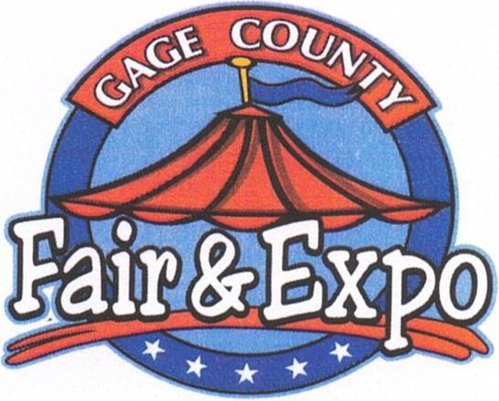
GAGE COUNTY AGRICULTURE SOCIETY

P.O. Box 671
Beatrice, NE 68310
402.223.FAIR (3247)
www.gagecountyfair.com
tttGAGE f t; f

On an attached page, please prepare a statement (500 words or less) to the following questions. The statement you make is valuable to the committee, in making the decision on your application.

- How has your participating in 4-H and the livestock premium auction helped you grow as an individual, and how will you apply what you've learned from these events in the future?

- Has there been a time in your life that your character was challenged (i.e. you were called to forgive, step-in to help another individual, had to take a higher road to avoid peer pressure to do something harmful)?
Describe the situation and how you handled it. Did your 4-H/FFA education play a part in your decision making? If so, please elaborate.

Please return this application, essay and letter of recommendation by March 15.
Mail to: Gage County Agriculture Society c/o Evie Crawford Scholarship Box 671
Beatrice, NE 68310

Recipients will be notified by June 1st pending participating in the 2024 Livestock Premium Auction.
The $500 Scholarship will be paid to the recipient and the institution of his/ her choice jointly, when proof of enrollment and acceptance by the school has taken place.
I certify that the statements made by me in this application are true, complete and correct to the best of my knowledge and belief, and are made in good faith.
Signature
Date

